## **📦 Global Logistics & Supply Chain Management System**

### **🧩 1. Objective**

* To manage and monitor global shipments effectively.
* Track storage, transportation, and customs processes.
* Ensure smooth operation across clients, warehouses, and carriers.

### **🗺️ 2. ER Diagram**

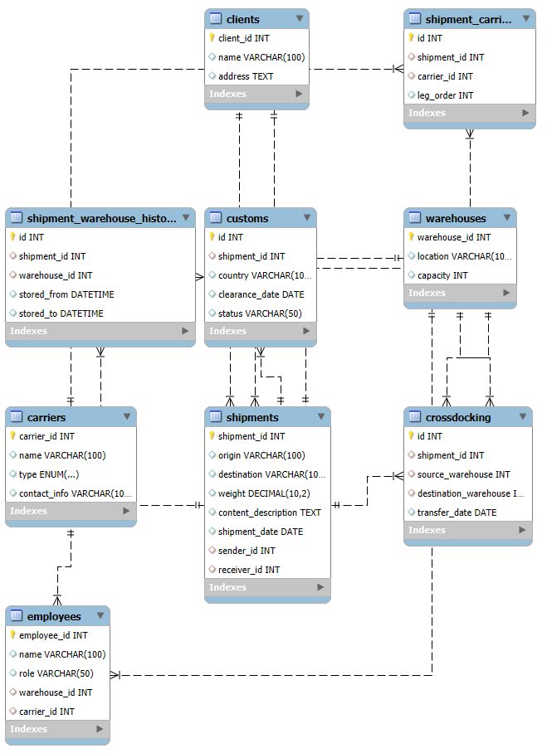 This diagram showcases how clients, carriers, shipments, warehouses, employees, and logistics operations are connected.

### **📑 3. Core Entities**

#### **✅ Clients**

* Unique client ID, name, and address.
* Clients can **send and receive shipments**.

#### **✅ Carriers**

* Represent transportation companies.
* Type: **Air, Land, Sea**.
* Each carrier can be responsible for **one or more shipment legs**.

#### **✅ Warehouses**

* Store shipments during transit.
* Each has **location** and **capacity**.
* A shipment is stored in **only one warehouse at a time**, but can change locations.

#### **✅ Employees**

* Assigned to either a **carrier or warehouse**, not both.
* Roles include **carrier crew** or **warehouse staff**.

#### **✅ Shipments**

* Key attributes: origin, destination, weight, content, and date.
* Linked to **sender and receiver clients**.
* Connected to multiple **carriers** and **warehouses** through tracking tables.

### **🔀 4. Relationship Tables**

#### **🔄 Shipment_Carriers**

* Tracks **each leg** of the shipment’s journey.
* Allows different carriers for different parts of the route.

#### **🏢 Shipment_Warehouse_History**

* Tracks **entry and exit** times from warehouses.
* Shows full storage history of each shipment.

#### **🌍 Customs**

* Records **clearance status** for international shipments.
* Logs country, status (e.g., pending/cleared), and date.

#### **🔁 CrossDocking**

* Manages direct **transfers between warehouses**.
* Supports efficient shipment movement with minimal delays.

### **🧠 5. Business Rules & Constraints**

* A **shipment can be in one warehouse at any given time**.
* **Multiple carriers** may be involved per shipment (in sequence).
* Clients can **act as sender and/or receiver**.
* **Employees can only belong to one domain**: warehouse or carrier.
* **Cross-docking** ensures rapid movement without long storage.
* **Customs** ensure compliance with international regulations.

### **🌐 6. Real-world Applications**

* **Global Shipping**: Handles customs, multiple legs, and client involvement.
* **Warehouse Management**: Tracks where and when shipments are stored.
* **Carrier Coordination**: Manages delivery chains with multiple transport modes.
* **Employee Assignment**: Differentiates roles and improves workforce clarity.

### **🧾 7. Conclusion**

This database schema:

* 📌 **Integrates multiple logistics functions**
* 📌 **Supports international and multi-modal transport**
* 📌 **Tracks full shipment lifecycle from origin to destination**
* 📌 **Improves transparency and accountability across the supply chain**